

Student Name: Charlie Coad
Student Number: 20102084
Course: Business Information Systems
Module: Big Data Analytics 2
CA No.: 2
Lecturer: Mrinal Chadha
Submission Date: 05/12/2025

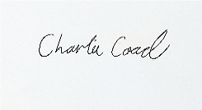
Signed: Date: 05/12/2025

Table of Contents
Task 1 3
Outputs of Task 1 5
Task 2 10
Outputs of Task 2 11
Task 3 12
Outputs of Task 3 14
Task 4 15
Outputs of Task 4 16
Task 5 17
Outputs of Task 5 19
Task 6 21
Outputs of Task 6 24
Task 7 28
Outputs of Task 7 30
Task 8 32
Outputs of Task 8 35

Task 1
For this task I was instructed to create a text file containing business related textual data, load the data into my RDD and then incorporate appropriate transformations. Then I was required to preform actions to collect, count and foreach to analyse the data and display my results.
I decided to first create a text file containing some restaurant reviews which I then pulled into an RDD using the “sc.textfile” function to locate it on my pc. Next I then split my reviews onto each word using the flatMap function and the split action. This was in order to count how many words was in the txt file.
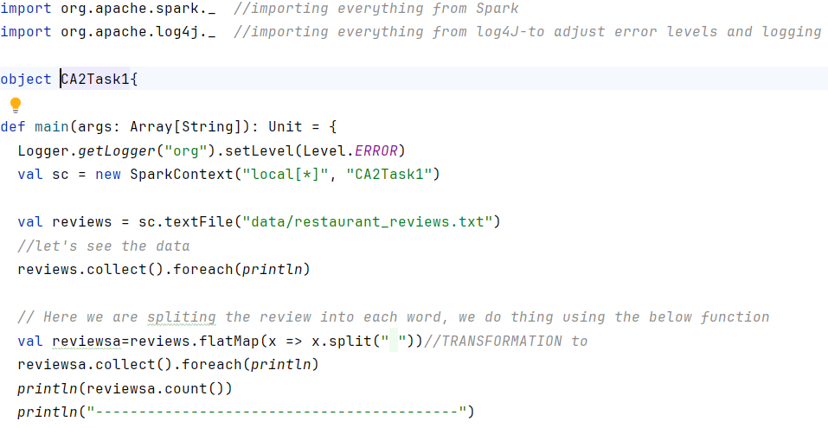

Next I associate each value with a number using the map function, this is to set up my next value function which would use the “reduceByKey” action to show the business how many words are repeated in the reviews. Then I created a function to sort each word out alphabetically. Next I utilized a function that would filter out the txt file to only show the words containing the letter “b”. I did “b” specifically as a business may was to find specific terms when analysing reviews, such as “bad” or “terrible”.
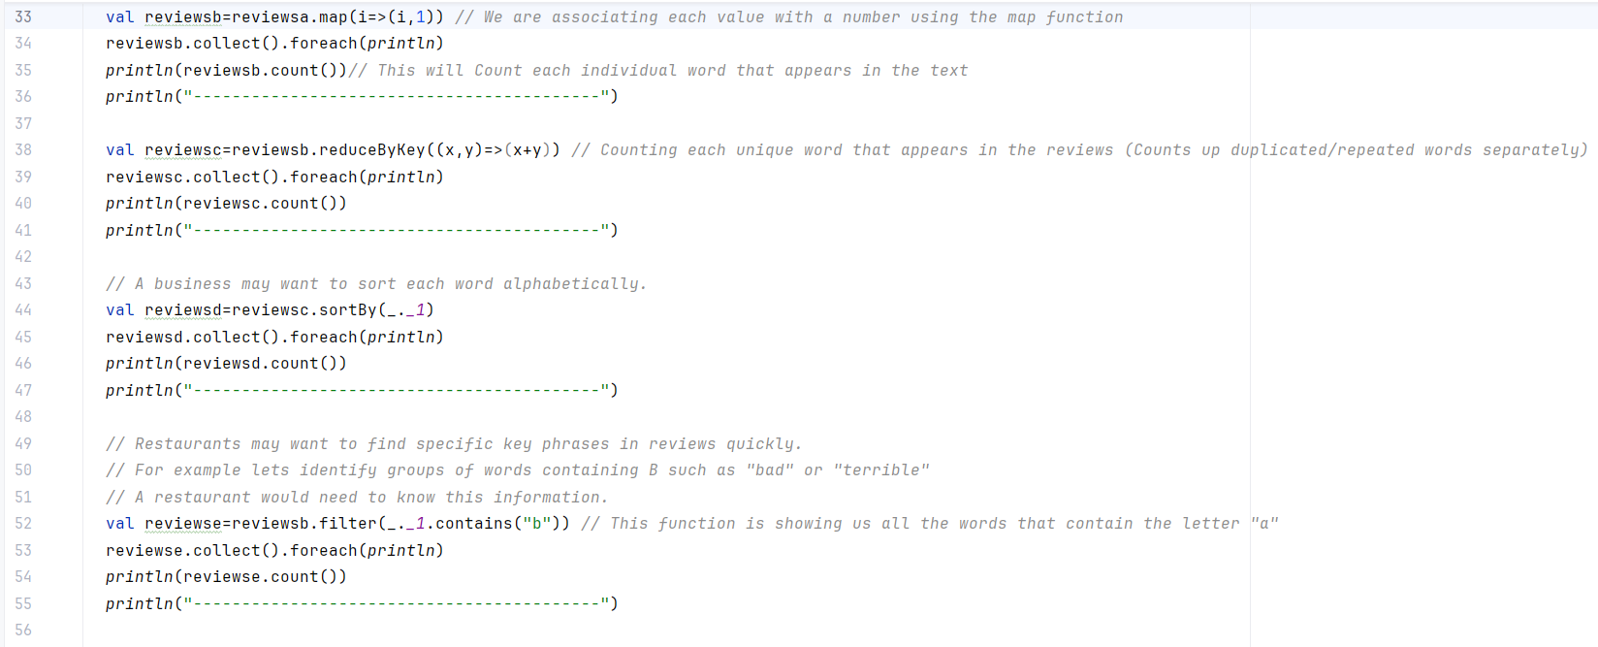
Finally, I created a final value that would filter out how many times the word “Delicious” appears in the reviews. This is an important function to use as a business may want to find specific words to put in there advertising or make business decisions based on customer reviews.
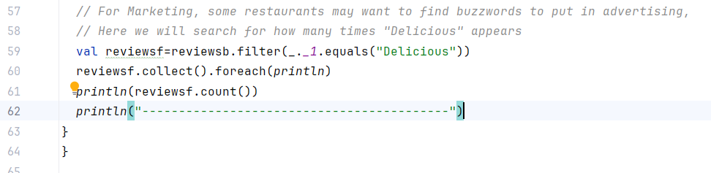

Outputs of Task 1

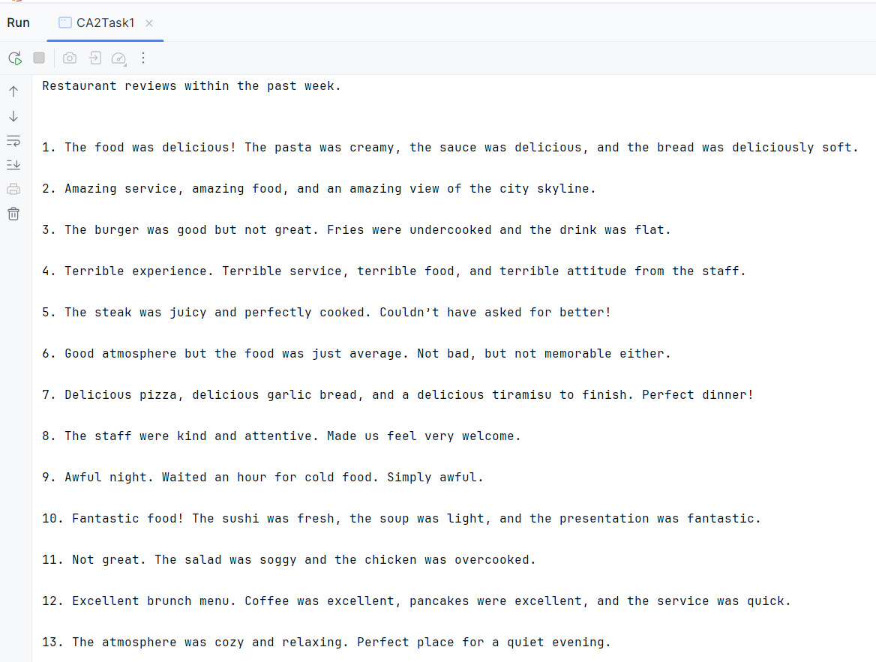
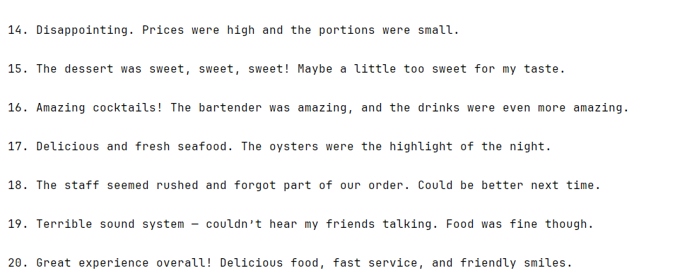
First the entire is texted is printed.

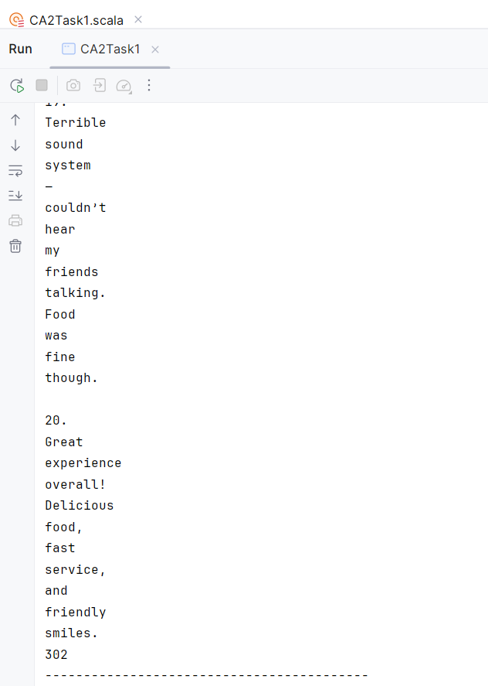

Then the Text is split meaning it is displayed vertically, and each word is counted. This tells us the text of reviews has 302 words altogether.
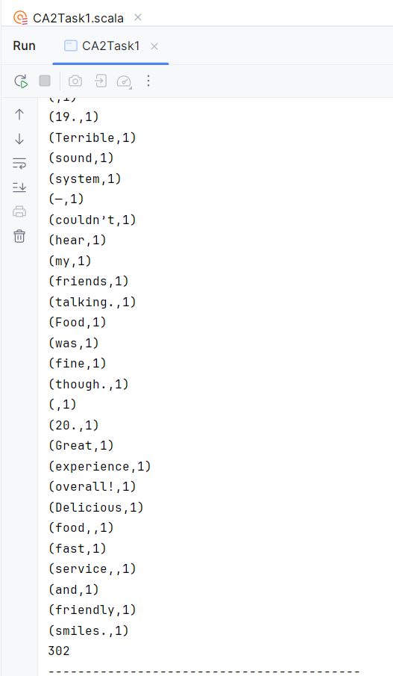
Next, we associate each word with a number, in this case the number is 1.
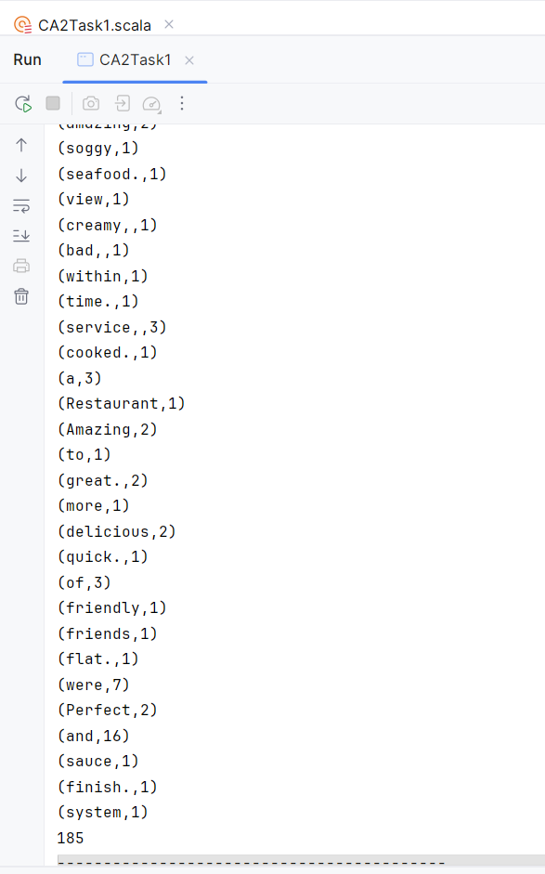
Here each word is being counted but now duplicated/repeated words are being counted separately each time they appear, giving us 185 unique characters/words.
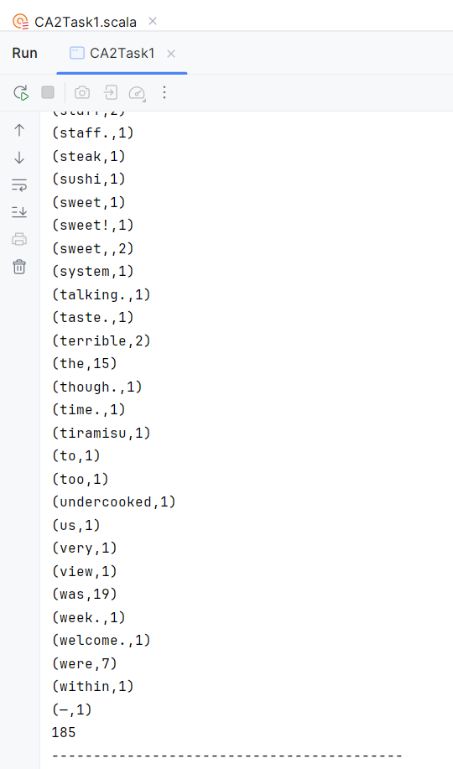
Here each word is being displayed in alphabetical order and each repeated word is counted each time appears.
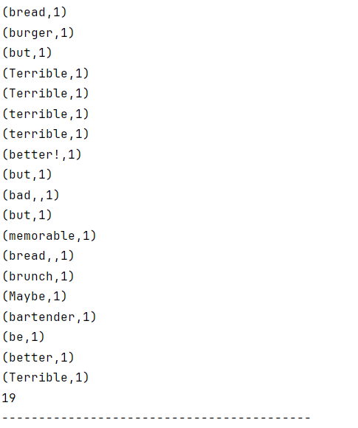
This is showing us every word with the letter ‘b’ that appears in the reviews.
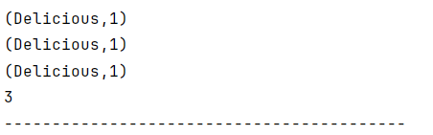
Finally this shows us each time Delicious appears in the reviews.

Task 2
For this task I needed to extract sample data from an RDD containing business related numerical data. For this I decided to create a scenario where a business may want to take a sample of their latest customer transactions to get a better understanding of what is the average amount of money their customers are spending on their products.
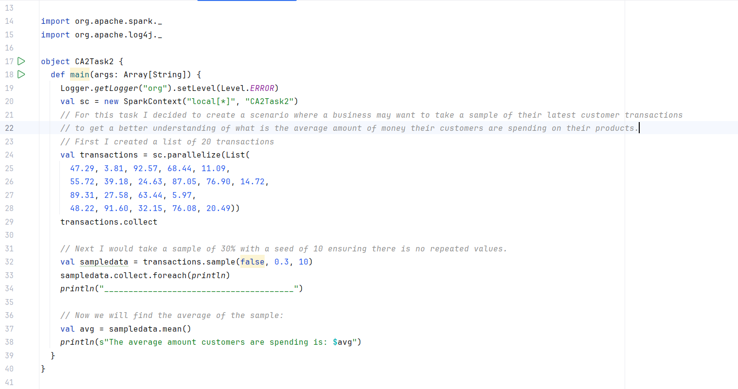
As we can see above, I created a list of 20 customer transactions and then utilising the “sample” action I would only analyse 30% of the sample with a seed of 10. I also needed to ensure that there were no repeated values as to not create a biased average. I have also written a function that will then look for the mean of the sample and generate it in the output.
I also want to put emphasis on that seeds as while in the above example we see a seed of 10 and this will generate a unique sample. However, If I change this seen to a different number it will provide me with a different unique sample. Below I will demonstrate this:

Outputs of Task 2
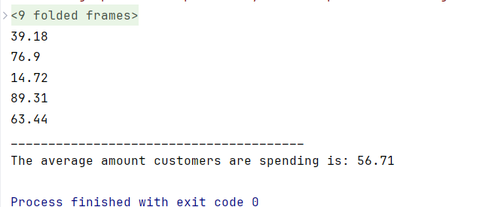
The output of this program was that it provides us with a sample of 30% of the 20 customer transactions, it also provides us with the average amount that the customers are spending based on the sample which in this example is €56.71. This is all based on the sample that is generated based on a seed of 10. If we change this to 5, this will generate instead:
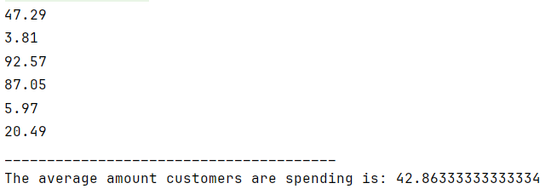
This demonstrates how different seed numbers will generate different samples. Resulting in this case in a different average.
These sampling techniques are very relevant within a business context as I have demonstrated above for analysing things like averages of customer expenditure however these can also be used to learn more about the customer, market trends or improving the business internally. Another example of these would be conducting customer satisfaction surveys, business can take an appropriate sample size and analyse the answers to help them gain new perspectives on customer satisfactions or dissatisfactions. Utilising seeds can provide them with even more randomised samples resulting in less biased perspectives and more accurate results.

Task 3
In this Task, I was tasked with Creating and analysing 2 RDD’s and within a business context, unify them together into one RDD. I was also tasked creating a third RDD with utilising mapPartitions in order to extract and print the first element of each partition of the RDD.
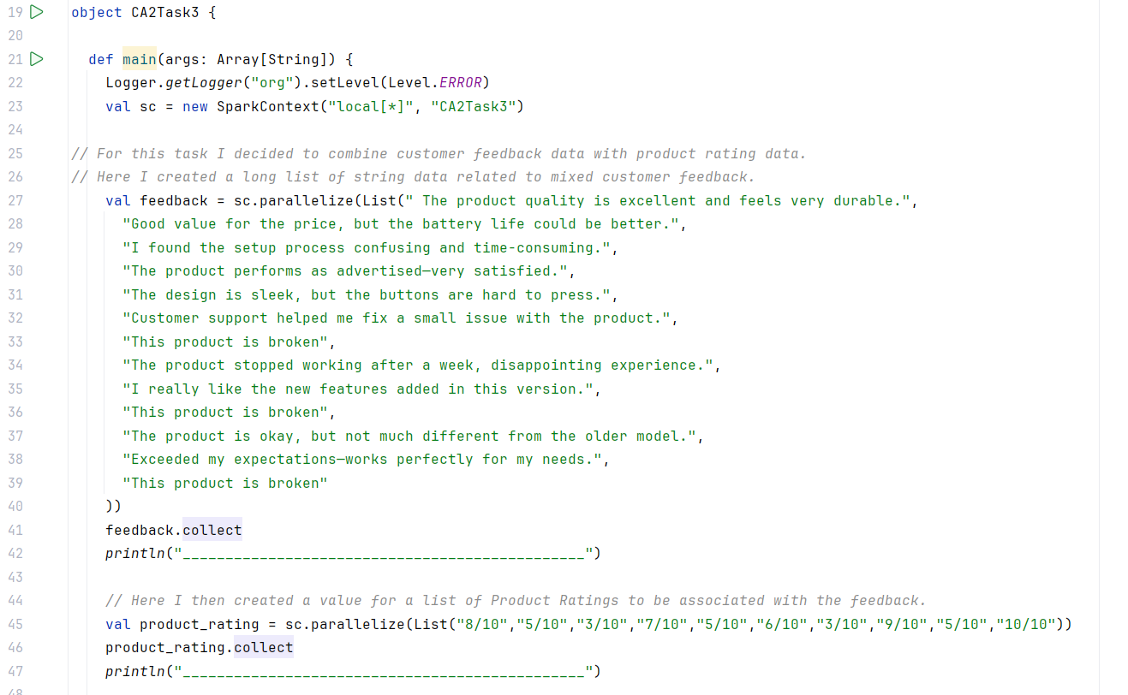
For this task, I decided to combine customer feedback data with product rating data. First I created a list called “feedback” where I generated mixed feedback data with some repeating feedback to filter out later. Then I generated another value called “product rating” which were also string values of customer ratings of different products. 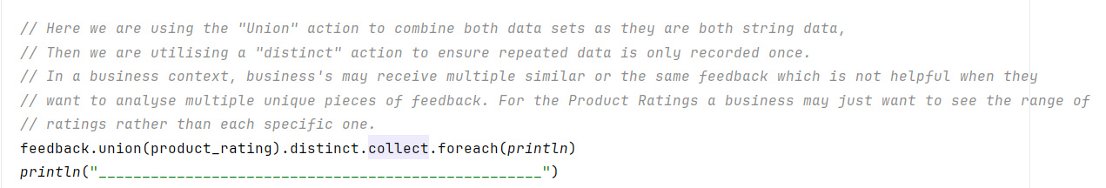
I then utilised the union action to combine both datasets together as they are both string data. I utilised the distinct action in order to ensure any data that is recorded, is only recorded once. This is because for the purposes of this analysis the business wants to only analyse unique pieces of feedback rather than feedback that is repeating all the time. In regards to Product Ratings, the business may just want to see the range of ratings they are receiving. For example if they are seeing a small range of 7/10 – 10/10 that would indicate that customers are overall happy with their products.
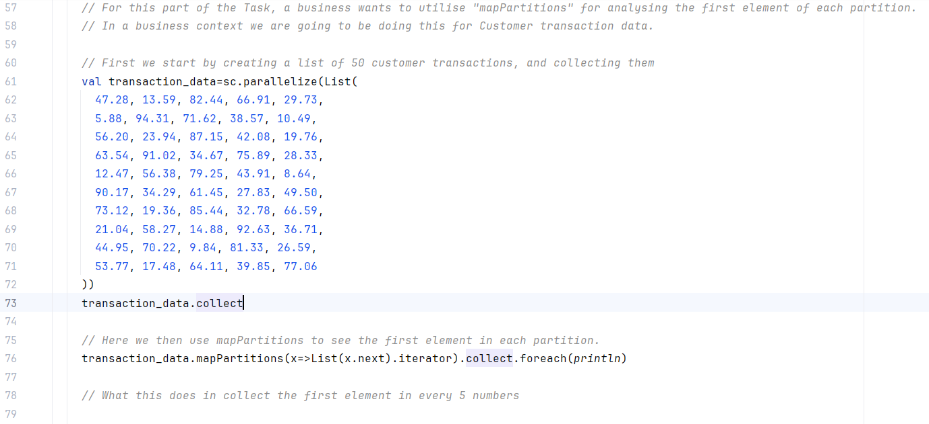
For this part of the task I created a new RDD consisting of 50 pieces of customer transactional data. I utilised mapPartitions” in order to analyse the first element of each partition. Which is what this will output.

Outputs of Task 3
In the first half of the outputs we can see the outcome of the Union action, where both RDD’s (feedback and product ratings) have been combined into one RDD. The results of this in regards to Product Rating’s show us a range from 3-10 which is a wide gap in customer satisfaction, data that a business could take and utilise in order to help meet these expectations more effectively.
In the second half of the outputs, we can see the output of the customer transactions partitions as it is detailing the first element of each partition. In this case it is generating the first element every 5-6 integers. In a business context this action could be utilised in gathering sample data to be analysed.

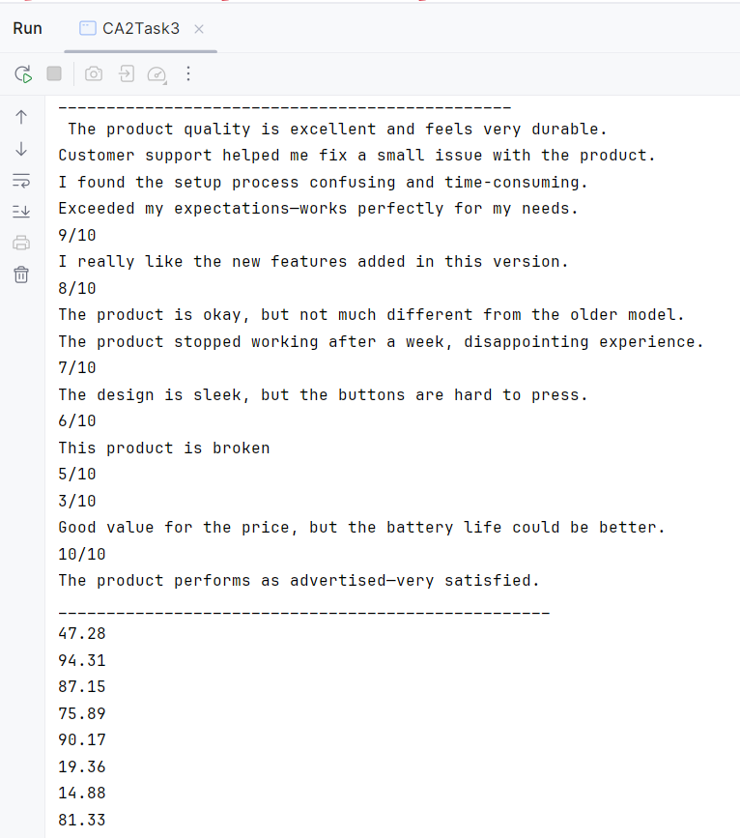

Task 4
For this task, I was instructed to define a User Defined Function (UDF) that will process data in an RDD that I create in order to address an identified business challenge.
For this I decided to tackle the business challenge of generating a working roster for a business as this is a common task that managers need to create on a weekly/monthly basis.
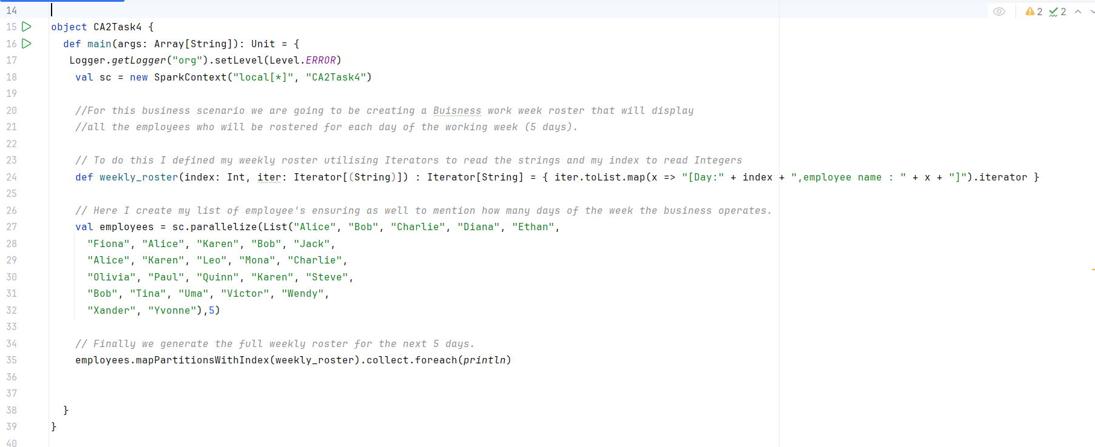
To begin I needed to define my UDF where I defined my Index as an Integer, my Iterator as a string and then mapping it using a iterator and listing function. As you will see later, this will generate a layout consisting of: “Day”, (day number), “employee name”, (the actual name of the employee. Next I created my list of 25 employee’s scheduled to work that particular week. It was also important that I needed to specify how many partitions I needed from this list, for this scenario the business only opens 5 days during the week so I specified to generate 5 days of people needing to be rostered. Finally I then needed to map the Partition with the index and print.

Outputs of Task 4
In this output we can see that it has generated a weekly roster where over the next 5 days (Days 0-4) there will be 5 employee’s rostered for each of the 5 days. We can also notice there are some repeating names on this roster which should be expected in a business as there are typically people working multiple days during the week.

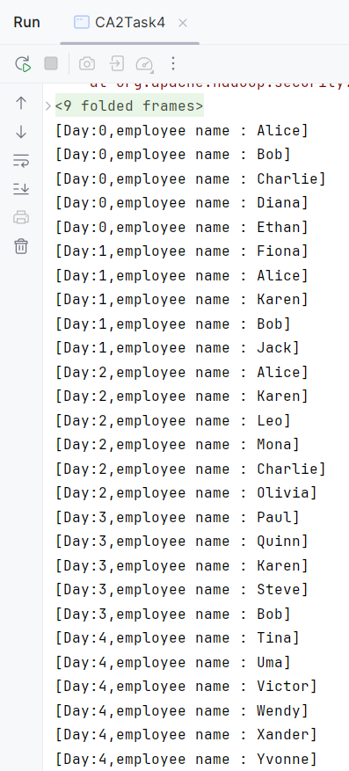

Task 5
For this task I needed to address an appropriate business scenario by constructing RDD’s, transforming them into DataFrames and then analysing these using SQL queries.
For this example I picked to create a Dataframe that would analyse what a business sold in a week and analysing that data. For this I would need to create 3 RDD’s consisting of data about a business’s Day of the week, Units sold that day and how much Sales were accumulated that day. First I created a value called spark to build my spark session. After this I began to create my columns as we can see below. I utilised the “spark.sparkContext.parallelize” action in order to create an RDD with the appropriate data. This was simple to do for the “Days” and “Units Sold” column as I used lists to fill the RDD’s. To create the “Sales” column I utilised the map function to generate the sales data from the “Units Sold” data.
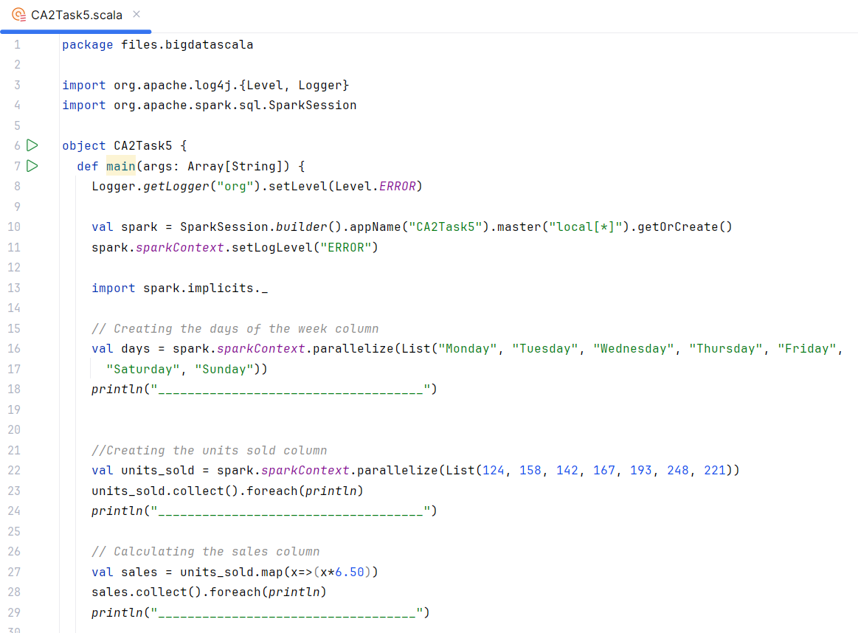

Next I needed to transform all these RDD’s into a single Data Frame. To do this for these 3 columns, I utilised the zip function in order to combine all the RDD’s together and in the right order. However the important thing to note here is that when we use zip on more than 2 RDD’s it creates a nested tuple in order to be combined. In order to get rid of the nested tuple, I utilised the “case” function to combine all of the datasets together.
Now that my RDD’s were merged, the next thing I needed to do in order to begin running queries was to transform my RDD’s into a data frame. I did this by using the “combined.toDF” function to put my data into columns and ensured all columns were given appropriate headings.
The final thing here was to now register my data frame as a table. I did this by utilising the “createOrReplaceTempView” function which would allow me to now run SQL queries.
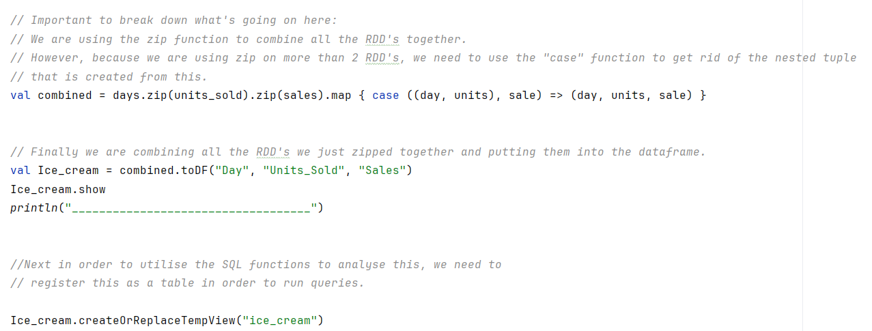

Now it was time to run some business-related queries a business may use to analyse this data. First a business may want to filter their data to see what data was generated for a specific day of the week, then they might want to only see specific days of the week. Next the business will want to see what was the most amount of Sales they made that week in a since day. Finally they will want to see: what was the largest amount of units they sold that week on a single day?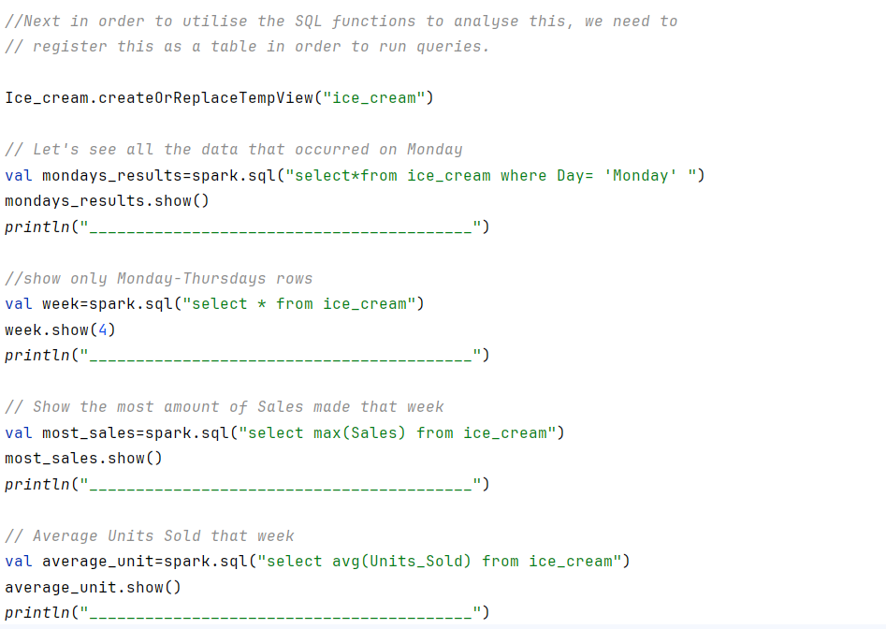

Outputs of Task 5
Here we can see the printed lists for the Units Sold, Sales and then the final result of a completed data frame in a table form with every dataset attached.
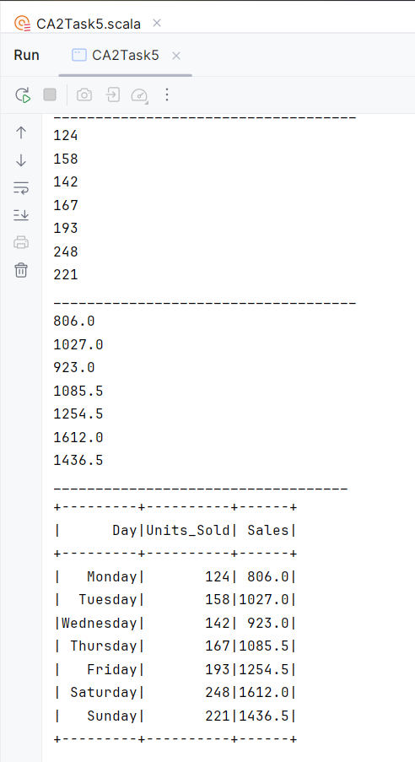

In these results we can see the outcome of the SQL queries, It can be seen clearly all the data found on Monday, the filtered data of just the mid-week data from Monday-Thursday. In the third result we see what were the most sales they made in a single day, which was €1,612. Finally, we can see; what was the largest amount of Units sold in a single day, which was 179 units sold. This is all very important data that business can analyse using SQL queries once their RDD’s have been transformed into Data frames as they provide a greater insight into the business performance from week to week. In this example we could see how the business tended to perform better during the weekend then during the mid-week period.
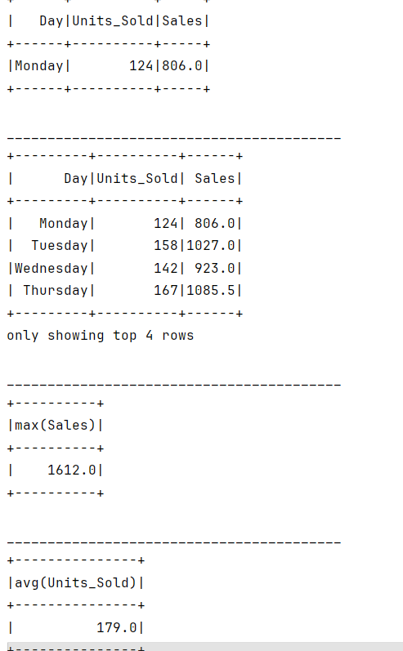

Task 6
For this Task I was required to find some Stock Market data, import it into my RDD and to then analyse its various price metrics.
I decided to analyse Microsoft Stock Market data from the past 5 years that I acquired from Nasdaq.
To begin I needed to define my case class my Stock Price data, I did this by classifying each field and associating each with either a String or a Float as where appropriate.
Next after defining my object, def main, Logger, spark value and importing the spark implicit, it was then time to begin importing the data. I used the textFile function and entered my file location as per my PC and collected the data.
Next, I needed to define the header and then filter it out of the analysis. This is important as Spark won’t recognise these as headers and would otherwise try and analyse these which we don’t want to do. This way we are also not manually altering any current data.
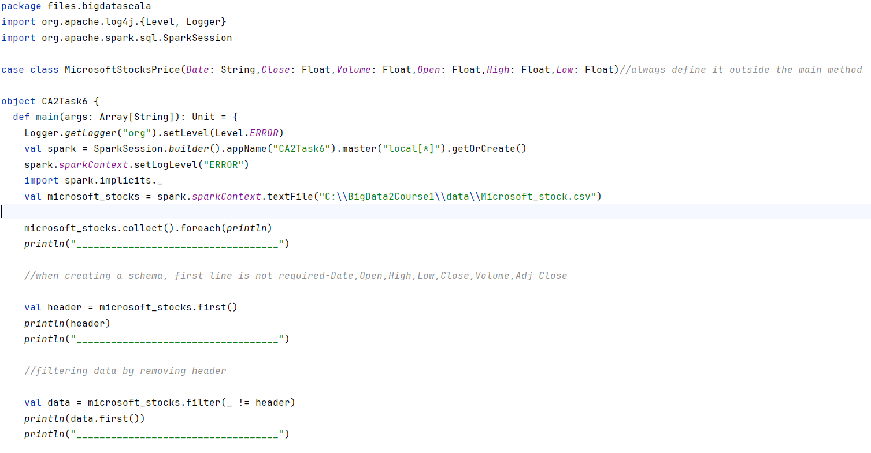

Then I needed to split the data up to create separate columns of the data by associating each column of data with a row. First was the Date, which since it’s a string it doesn’t not need to be trimmed. The rest of the rows however to need to be trimmed to a Float as they are currently larger then a float. As part of this function, we are also converting these rows into a data frame using the “.toDF()” action.
Then I registered my newly created data frame as a table. This is important as it will allow me to run SQL queries on the data frame

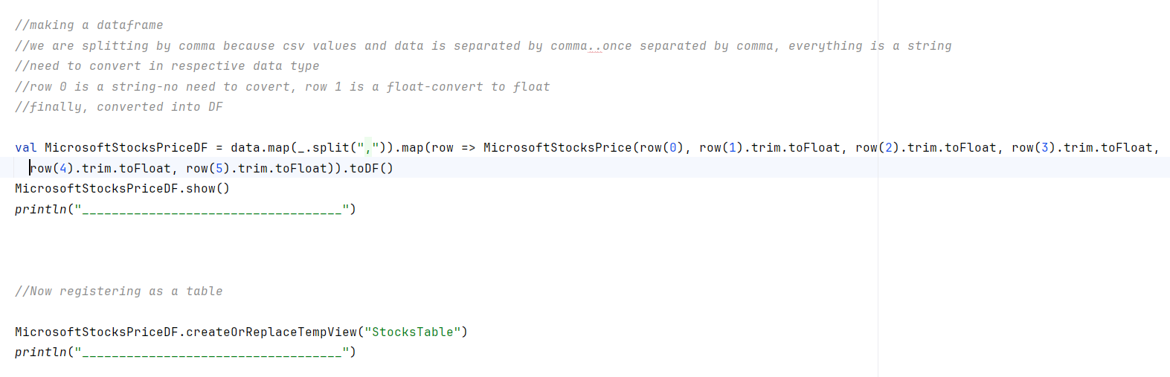
Now it is time to run the queries and analyse my stock data thoroughly.
First, I ran a query that would look at the maximum amount of Opening Price over the past 5 years. Secondly, I ran a query that looked at the Highest closing price over the past 5 years. Thirdly, I wanted to see the average trading volume overall. Then I wanted to see specifically all the stocks data from the 9th of January 2023. Finally, I wanted to see the first 25 rows.
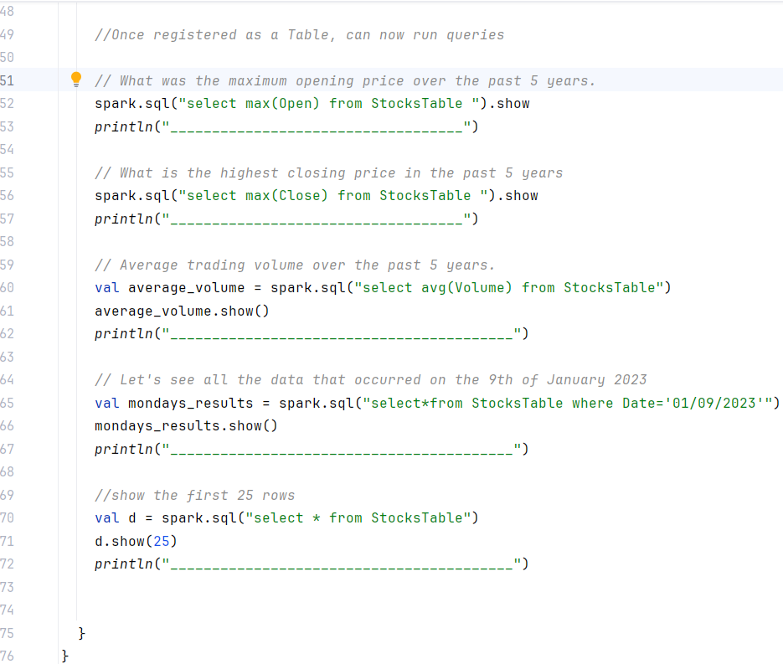

Outputs of Task 6
The first output here is the full amount of Microsoft stocks being printed. Then I printed out the headings each stock column. Thirdly we get the newly filtered out first row which in this case as we have filtered the headings out of the analyses is the latest stock figure.
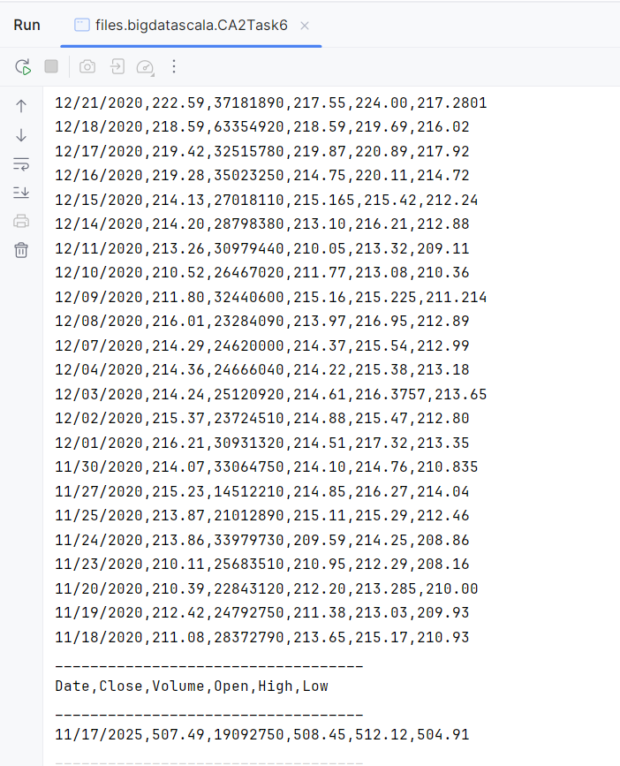

The next output is the result of the function used to generate transform the RDD’s into the Data Frame.
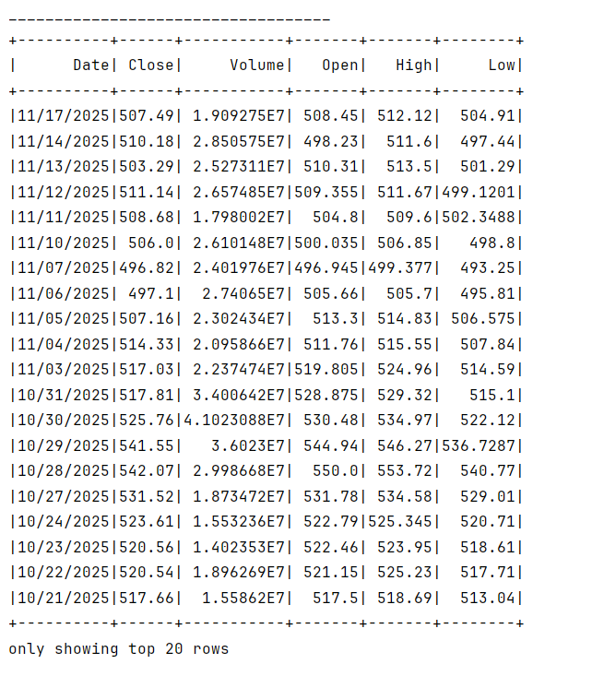

The next output is the result of the maximum opening price figure which here gives us $555.225. Next is the result of the highest closing price figure which outputs $542.07
After this the outputs provides the result of the average trading volume which is 2.560517…
The next output is the result of the figures of the Microsoft stock data from the 9th of January 2023.
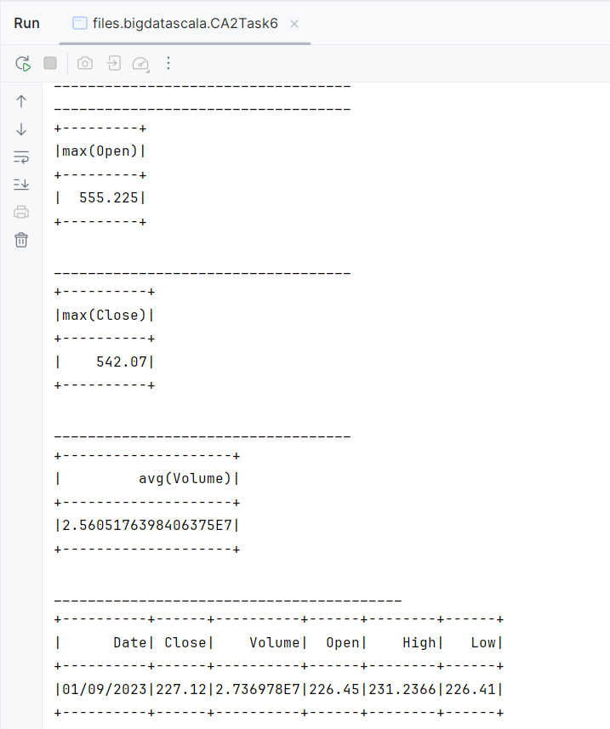

The final output I got from this task was the output of the first 25 rows of data in the Microsoft stock data:
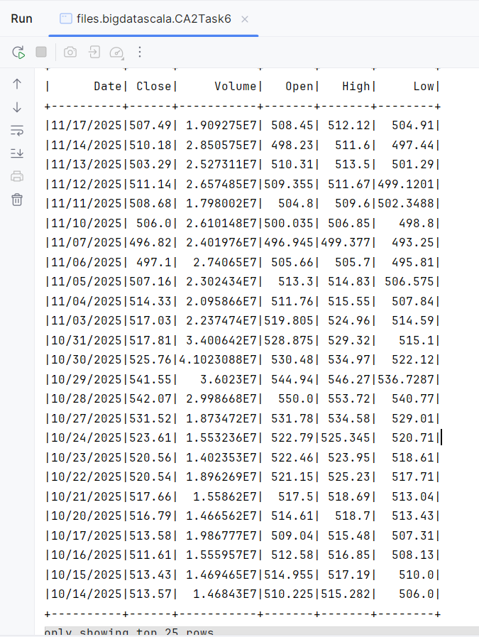

Task 7
For this task I was instructed to Define a schema using the Struct Type and analyse Product Data
I began this task by importing all the appropriate Apache spark requirements, defining my object, def main and Loggers. Next I needed to create my Schema, I did this by using the “structtype” and “structfield” classes to specify my data types. For this task I decided to base it on a clothing store where I would be analysing data related to their, Products, (defined as a string type) Price, (defined as a float type) Units sold, (defined as a Integer type) and Sales (defined as a Integer type)
Then I built my session using the spark session builder associated with it with my local machine and then importing spark implicits.
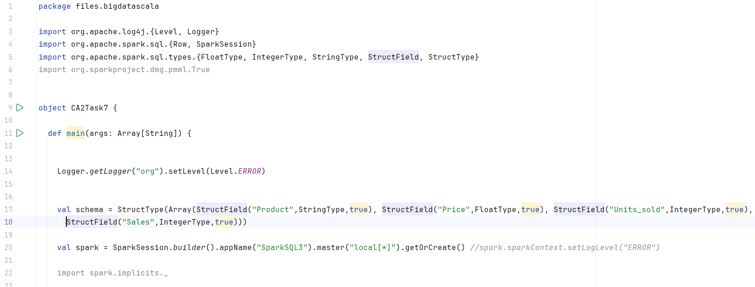
Next I created my datasets of RDD’s that I would be analysing:
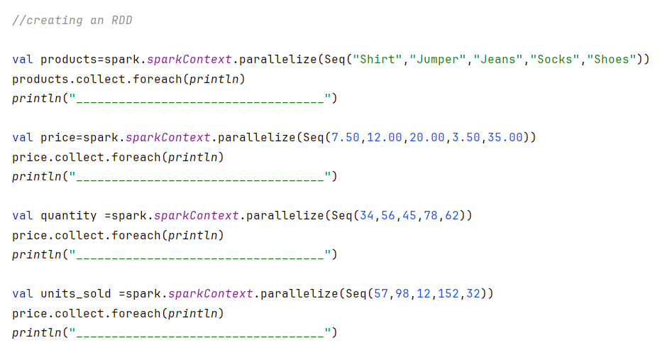

The next thing I did was to join my datasets together which I would do using the zip function. Its important to clarifying what is going on in this first function. 3 separate things are happening in this function:
- I am utilising the .map{case} function in order to get rid of the nested tuples that are created from zipping together 4 RDD’s
- Im utilising the “Row” function that allows me to transform the newly made RDD into a row.
- I am transforming the prices dataset into a float as currently that data is classified as a double due to the double decimals present in the dataset.
Im then collecting this data and printing it.
Next its then time to turn my row of data into a dataframe using the “create.DataFrame” action rather than the “.toDF” function as this is a Struct Type.
Then I transform the data frame into a table which will allow me to run SQL queries on it.
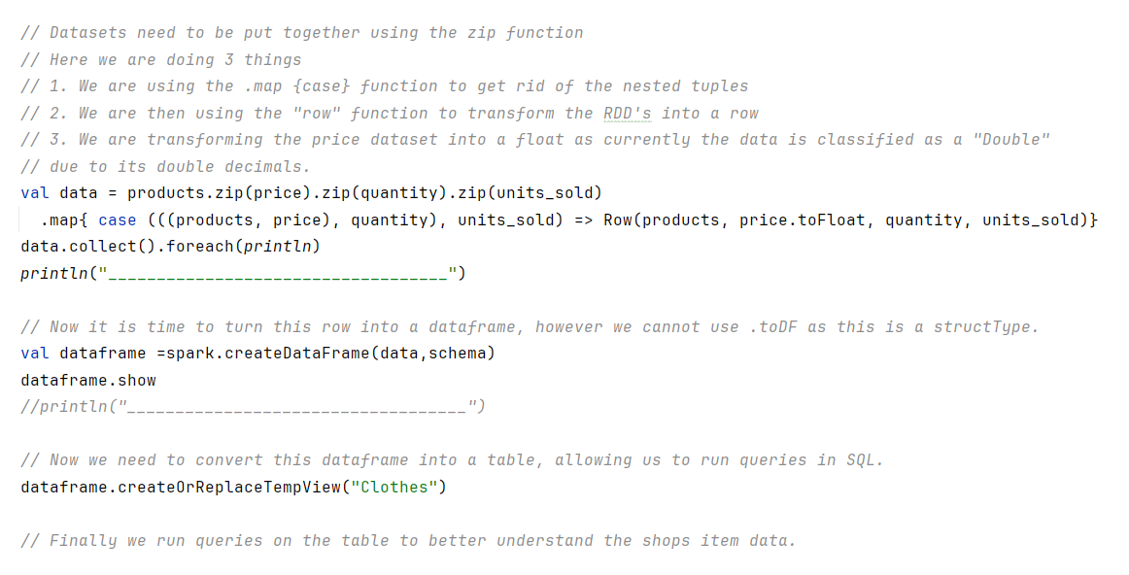
The queries I will run on the clothing stores items are as follows:
What product sold the least number of units, and the product that sold the most amount of units? To carry out this query. I wanted to ensure that the columns “Product” and “Units Sold” To carry this out I needed to select these columns and utilising the “where” action associated with “Units Sold” and equalling that to the minimum and maximum function of “Units Sold”.
Next, I wanted to find the Total amount of Sales the store has made overall.
Finally, I wanted to find the average price that the stores customers are currently spending for their items.
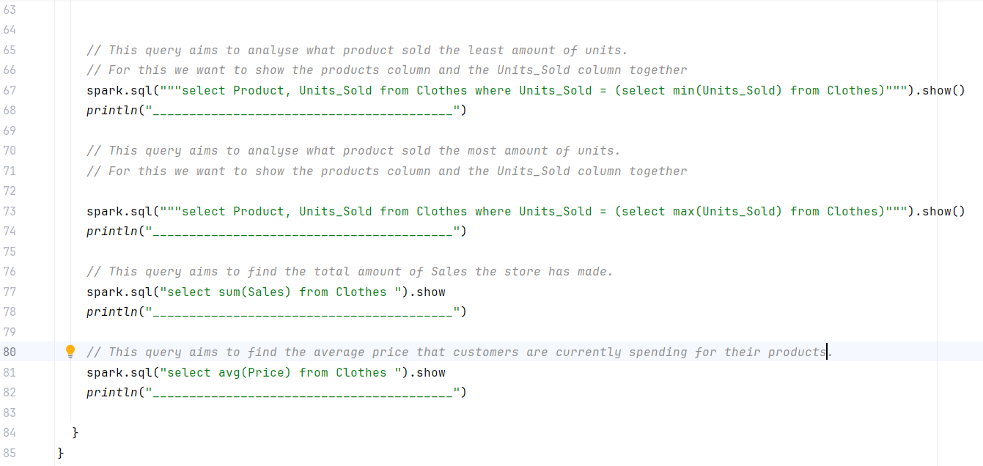

Outputs of Task 7
The first outputs that are printed are the dataset outputs:
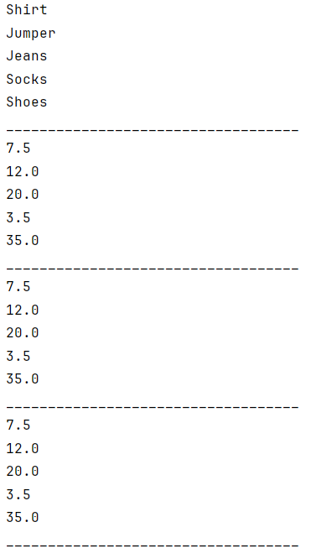
The next outputs are the result of putting the zipped RDD’s into a row and then the next output is after transforming them into a data frame format:
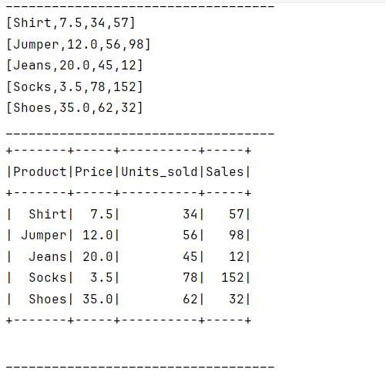
The final outputs are the results of the SQL queries: Here we can see the outputs of the least number of products the clothing store has sold, being they gave only sold 34 units of shirts. Below this we can see the maximum amount of product sold which are 78 units of Socks. Next, we can see the Store has sold 351 Sales overall from the data analysed. Finally, the average price that their customers are spending on their products is €15.60
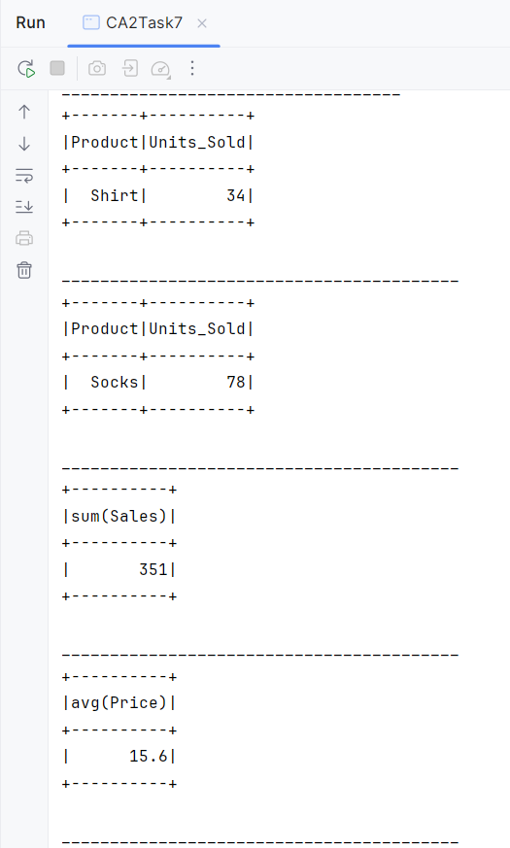

Task 8
For my final task I was required to add 10 rows of data to my transaction.csv file manually and then import this data directly into a Spark DataFrame, create a User Defined Function to address a relevant business problem related to the data and then generate new columns based on data transformations.
To start I added an extra 10 rows of data to the provided transaction.csx file:
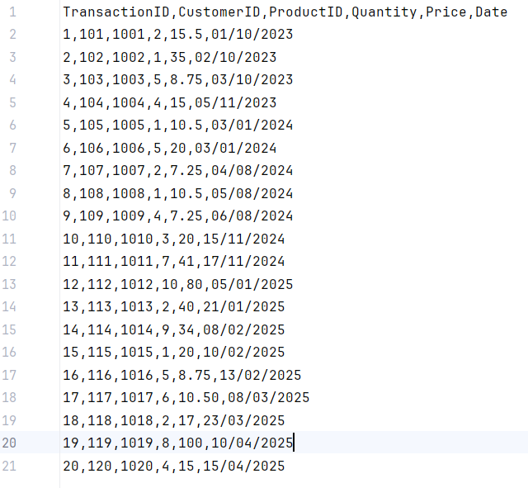
Next, I need to then import this directly into a Spark data frame. I did this by utilizing the “spark.read.format” action. Then showing and printing out the schema to go with it.
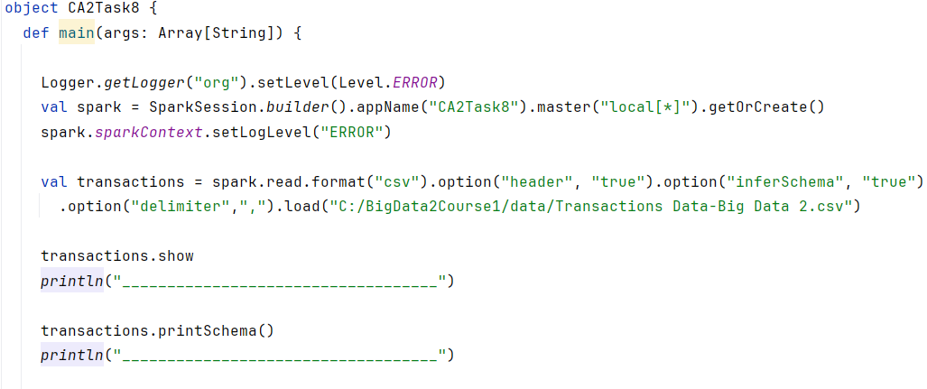
Now it was time to begin running analysis and queries on some of the data to get a better understanding.
This included looking into what customers are currently spending less that €30 euro in the store and what was the average amount of quantity being sold in the store?
For the first query it was important to include the customerID and Price being displayed in a table to a clearer understanding of the data.
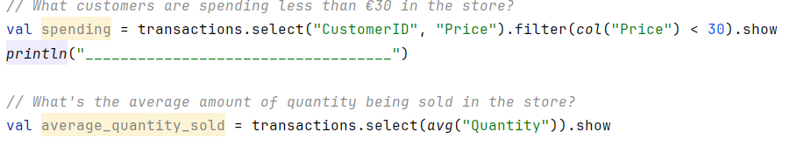
The current business problem I identified with this dataset was that it was missing a crucial piece of information: the sales data. To address this problem, I created a UDF and based on the data transformations below I was then able to add a “Sales” column to the dataset by multiplying the quantity columns data with the price columns data:
The first action I do here is to define my calculation, next I used the “udf” function to turn my previous definition into a UDF. Finally, then I can apply this to the Dataframe in order to generate my new “Sales” column.
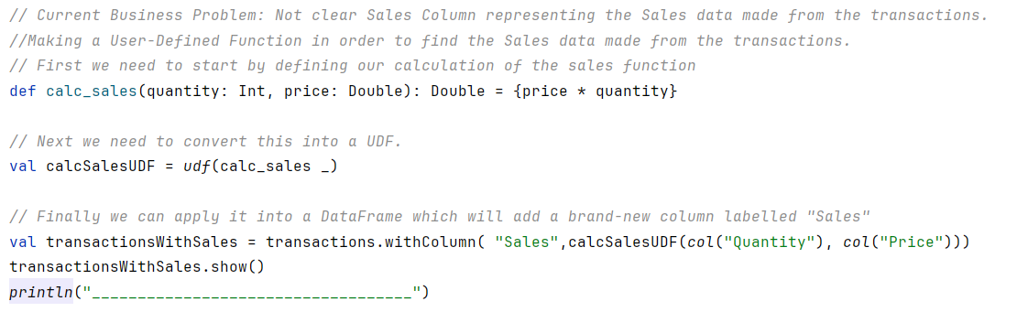
Another trend I wanted to analyse was what percentage of customers were spending more than €35 within the store. I did this calculation by first creating a value to find how many customers the store sold to overall, then another value to find how many customers are spending over €35. Finally in the third line I print out to divide the second value by the first and multiply by 100 to find the percentage of customers spending over €35.
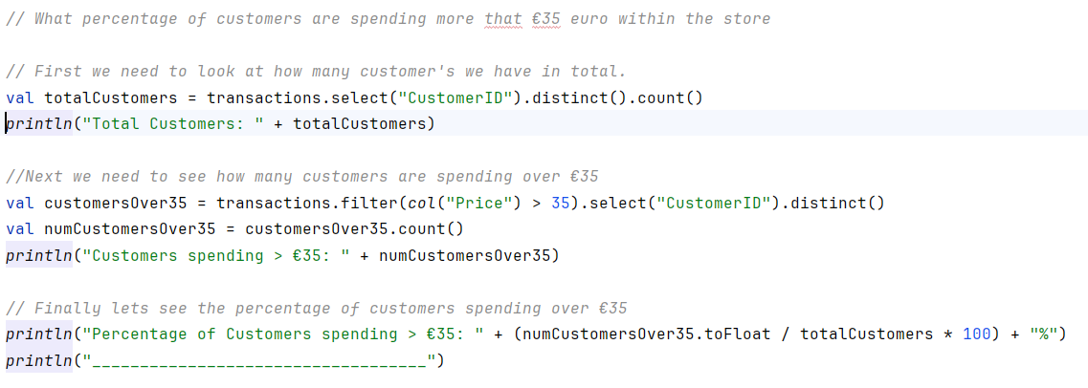

Outputs of Task 8
The first output’s I receive is the full csv after being imported into directly into the Spark data frame along with my printed schema to go with it:
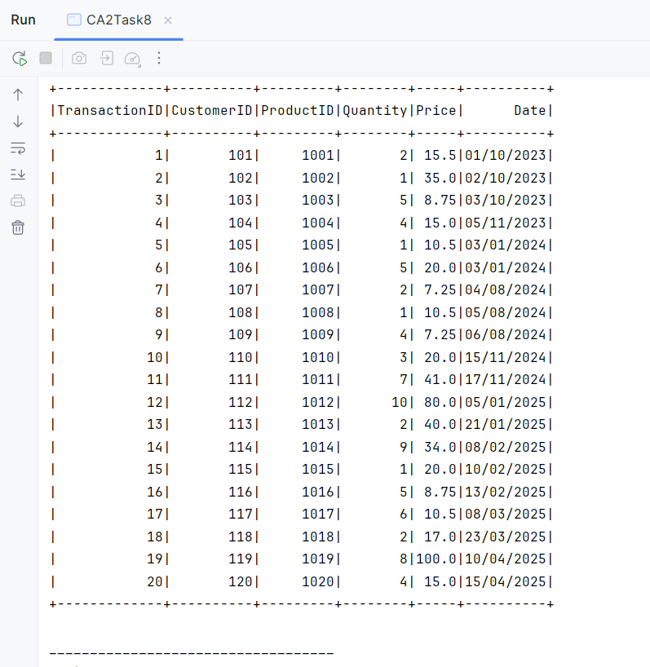
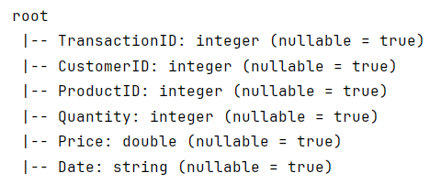
The next output that is printed is how many customer’s spent below €30 within the store:
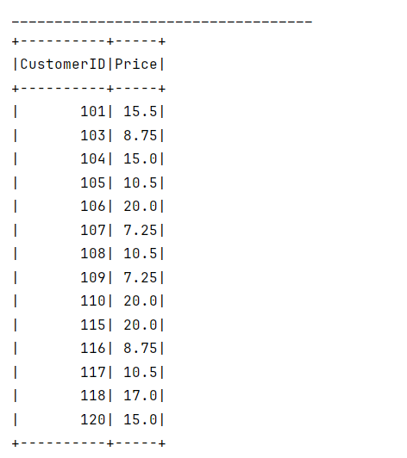

After this, the output of the average quantity of products sold in the store is printed:
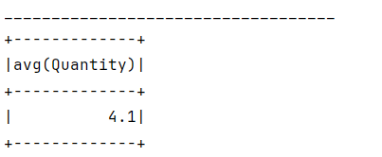

The next output is the result of the UDF and adding the Sales column dataset into the current dataset after multiplying the Quantity and Price data:
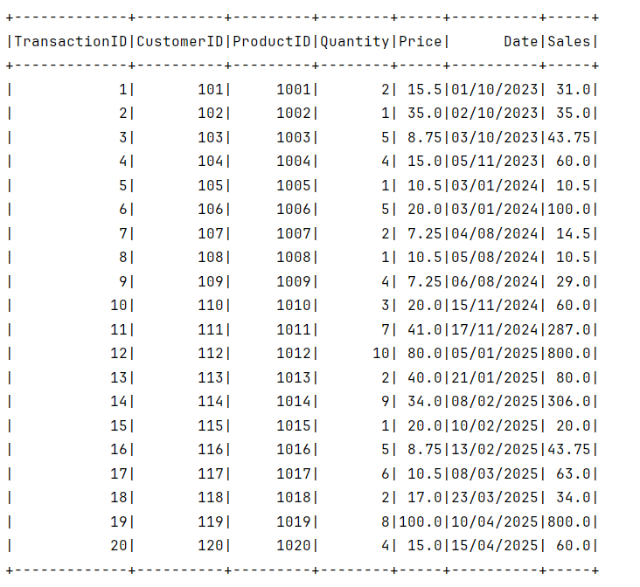

The final output is the result of the values created to find what percentage of customers that spent more that €35 in the store. This includes the total number of customers, the number of customers spending more that 35 and the percentage of customers spending more than 35.
